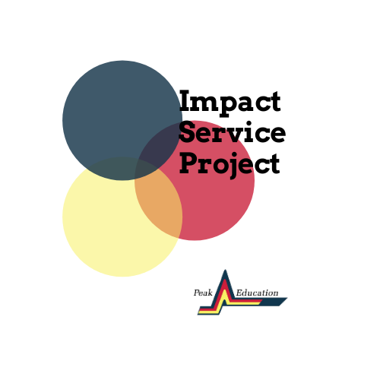
Project Partner Program Description

Overview
The Impact Service Project pairs Peak Education Scholars with local businesses, nonprofits, and educational institutions to solve some our community’s biggest challenges related to the COVID-19 pandemic. In response to problems identified by local businesses, nonprofits, and educational institutions, students will work in small group teams—with the support of a coach—to identify root causes of local area problems and identify solutions. After clearly defining the problem and proposing a resolution, each team will receive funding from a pool of $10,000 to support their efforts to generate tangible outcomes with positive impacts in our community. Project partners will work with the teams to evaluate the plan and progress.

Timeline
We are working to identify project partners in business, nonprofits, and education through the month of November. Once partners are identified, we will host a virtual orientation on December 16th at 5:30pm to review program details. This will serve as an opportunity for the partners to meet their team coaches and give a brief overview of their problem. Students teams will be announced December 11th and will begin their research after a kickoff event January 6th, 2021. Project proposals will be due at the end of February. During March, April, and May, teams will implement their proposed projects for project partners. Project reports will be due in mid-May.

Project Partners Description and Responsibilities
Project partners are expected to present a problem that they do not have an internal solution for. The problem should be challenging, but also tangible to be addressed in a 6-month timeframe. Project partners would be expected to formally meet with project teams 3 times throughout the course of the project:
- Meeting 1) Framing the problem and providing context and information that can inform the team’s research and approach
- Meeting 2) Review progress on the problem and begin to understand potential solutions prior to the team’s formal submission for review
- Meeting 3) Implementation of the solution
In addition to 3 meetings, project partners need to identify a primary point of contact that is available for questions or ongoing communications from a team coach and Peak Education.
Students will be receiving grants to assist with implementing the solution to the organizational problem. These grants cannot be used for general operating expenses and should be inly utilized directly with supporting the program development.

Contact
Please contact Lauren Taylor with any questions: lauren@peakedu.org

Project Partner Application:
https://peakedu.formstack.com/forms/l3_partner_application_copy

