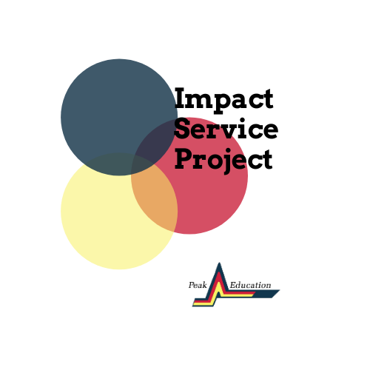
Project Partner Resource Guide
Program Milestones: | Date | Time | Location
Kick Off Event | January 6th, 2021 | 5:30pm | Zoom
Problem Exploration with Coach & Team | Date set by coach at orientation
Progress Check (Partners) | Due March 31st, 2021 | 11:59pm | Google Classroom
Final Review | May 31st, 2021 | 5:00pm | Google Classroom
Presentations, Awards, Trip | TBD
*Any additional communication/ meetings should be arranged with your team’s coach.

Project Partners Description and Responsibilities
Project partners are expected to present a problem that they do not have an internal solution for. The problem should be challenging, but also tangible to be addressed in a 6-month timeframe. Project partners would be expected to formally meet with project teams 3 times throughout the course of the project:
- Problem Exploration- Framing the problem and providing context and information that can inform the team’s research and approach
- Progress Check- Review progress on the problem and begin to understand potential solutions prior to the team’s formal submission for review
- Final Review- Discuss implementation of the solution, successes and challenges, complete final evaluation for your team.
In addition to the mandatory touchpoints listen above, partners are encouraged to communicate with Peak Education and their team’s coach throughout the project. The project presentations, award ceremony, and final outcomes will be scheduled at a later time to address the ever-changing nature of the COVID-19 pandemic.

Contact
Please contact Lauren Taylor with any questions: lauren@peakedu.org
Final Evaluation:
https://peakedu.formstack.com/forms/final_evaluation

