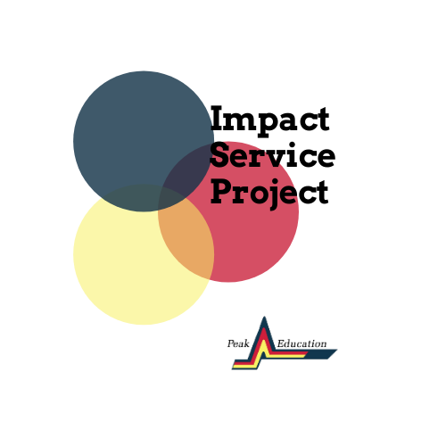
Student Program Description

Overview
By participating in the Impact Service Project, Peak Education Scholars will have the chance to take on some of our community’s biggest challenges related to the COVID-19 pandemic. In response to problems identified in local businesses, nonprofits, and educational institutions, students will work in small group teams—with the support of a coach—to identify root causes of local area problems and identify solutions. After clearly defining the problem and proposing a resolution, each team will receive funding* to support their efforts to generate tangible outcomes with positive impacts in our community.
As part of researching the problem they have been assigned, teams will meet with project partners to learn what challenges they are facing and how the team can help. After researching and listening, teams will submit a project proposal with a budget and a plan to implement a solution for their project partner. Coaches, staff, and the project partner will provide feedback on proposals. Teams will then implement feedback and execute their plan.
This project will benefit student participants (who will learn meaningful skills and help their community), coaches (who will mentor young people), and project partners (who will receive real resources to combat the novel challenges of this moment).

Timeline
Students must submit applications by November 30th, 2020 at 5 PM. Teams will be announced December 11th. Teams will begin their research after the kick-off event, January 6th. Project proposals will be due at the end of February. During March, April, and May, students will implement their proposed projects. Project reports will be due in mid-May.

Student Participant Description and Responsibilities
A special opportunity for Peak Education Scholars, this program is a chance to develop an idea from start to finish—from research to implementation. Not only is this a chance to learn new skills and add to a resume, it is an opportunity to put real resources to work to creatively solve a problem you see in your community. Furthermore, student participants will be eligible for cash prizes* from a $2,000 pool at the conclusion of the program! Participants must be prepared to collaborate, research independently, and receive feedback from their coaches and Peak Ed staff. Starting in January students are expected to commit around 2-5 hours (and occasionally more) per week on this project. This is a big commitment, but the payoff for hard work will be big as well.

Contact
Please contact Lauren Taylor with any questions
Lauren@peakedu.org

Student Participant Application:
https://peakedu.formstack.com/forms/l3_student_application

*Project funding, coach stipends, cash prizes, and travel funding are subject to change based on the number of participants and COVID-19 precautions.

